Week 3 Penetration Testing Report

Introduction
This report document hereby describes the proceedings and results of a Black Box security assessment conducted against the Week 3 Labs. The report hereby lists the findings and corresponding best practice mitigation actions and recommendations.
- Objective
The objective of the assessment was to uncover vulnerabilities in the Week 3 Labs and provide a final security assessment report comprising vulnerabilities, remediation strategy and recommendation guidelines to help mitigate the identified vulnerabilities and risks during the activity.
- Scope
This section defines the scope and boundaries of the project.
{Cross-Site Scripting}
Application Name
- Summary
Outlined is a Black Box Application Security assessment for the Week 3 Labs.

Total number of Sub-labs: 11 Sub-labs

High | Medium | Low
3 | 3 | 5

High - Number of Sub-labs with hard difficulty level Medium - Number of Sub-labs with Medium difficulty level Low - Number of Sub-labs with Easy difficulty level

  - {Cross-Site Scripting}
    - {Let’s do it!}

Reference | Risk Rating
Let’s Do IT! | Low
Tools Used
Google Chrome
Vulnerability Description
I found this vulnerability by entering simple javascript code into the client side reflection field, i.e., i successfully performed reflected xss.
How It Was Discovered
Manual Analysis
Vulnerable URLs
https://www.bugbountyhunter.org/internship_labs/HTML/xss_lab/lab_1/lab_1.php?email=%3Cscript% 3Ealert%28%22bunny+hacked+this%22%29%3C%2Fscript%3E
Consequences of not Fixing the Issue
XSS enables an attacker to inject client side code, so with this, an attacker will be able to capture client side cookies which can capture account credentials of any user.
Suggested Countermeasures
Developers must sanitize the input of any user by denying entry of any tag or any special character.
References
I found this basic vulnerability by entering a basic JavaScript tag. So, I did not take any help.
Proof of Concept
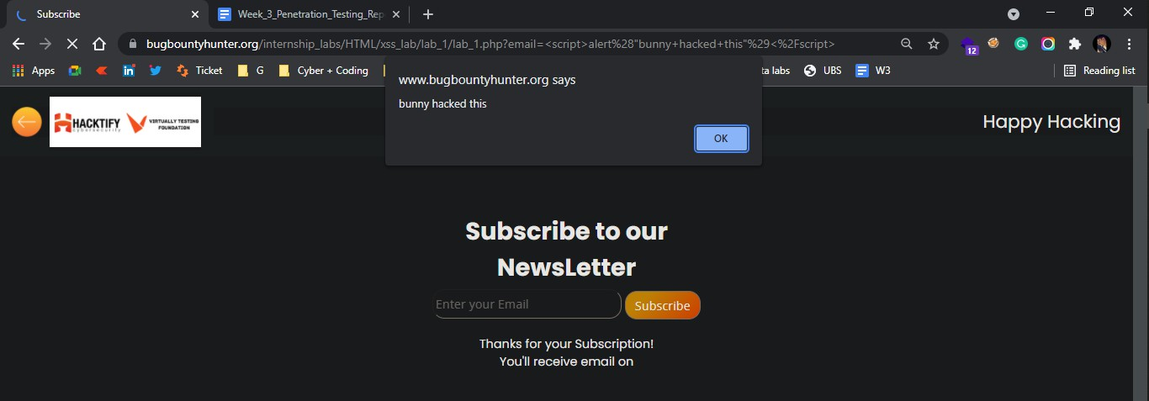

Reference | Risk Rating
Balancing is important in life | Low
Tools Used
Google chrome
Vulnerability Description
I found this vulnerability by modifying the URL after getting valid output as actually developed. Also, it will allow an attacker to carry out any action that the user is able to perform.
How It Was Discovered
Manual Analysis
Vulnerable URLs
https://www.bugbountyhunter.org/internship_labs/HTML/xss_lab/lab_2/lab_2.php?email=%22%3E%3 Cscript%3Ealert(%22bunny%20edited%20this%20snap%22)%3C/script%3E
Consequences of not Fixing the Issue
Carry out any action that the user is able to perform.
Suggested Countermeasures
Developers must sanitize the input of any user by denying entry of any tag or any special character. And
also illegal links of any web page should not display any valid output.
References
https://github.com/payloadbox/xss-payload-list

Proof of Concept
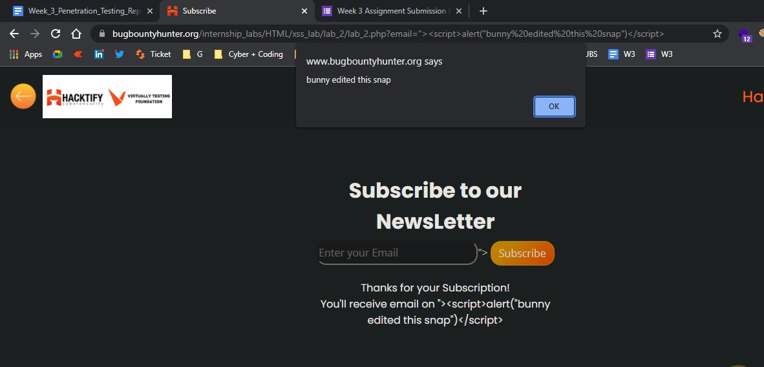

Reference | Risk Rating
XSS is everywhere! | Low
Tools Used
Google chrome
Vulnerability Description
I found this vulnerability by modifying the URL after getting valid output as actually developed. Here, the developer has given validation while developing this web page as the text field must contain a valid email address which will end with “@gmail.com”. If any other input is entered, then an error message will display called “Enter a valid email address”. So, to bypass this I simple inserted my payload which will end with provided validation for input, i.e., “@gmail.com”
How It Was Discovered
Manual Analysis
Vulnerable URLs
https://www.bugbountyhunter.org/internship_labs/HTML/xss_lab/lab_3/lab_3.php
Consequences of not Fixing the Issue
Carry out any action that the user is able to perform.
Suggested Countermeasures
Developers must sanitize the input of any user by denying entry of any tag or any special character if it is not a valid entry for that particular text field.
References
https://github.com/payloadbox/xss-payload-list

Proof of Concept
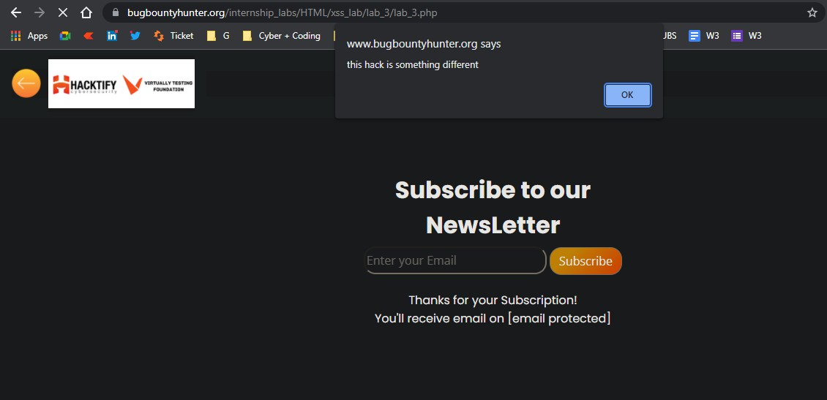

Reference | Risk Rating
Alternatives are a must | Medium
Tools Used
Google chrome
Vulnerability Description
I found this vulnerability by modifying the URL after getting valid output as actually developed. But, here the developer has sanitized the tag which is commonly used in JavaScript, i.e., alert(). So, to bypass this situation, I used the confirm() tag and I successfully got what I expected. Also, I am able to successfully run prompt() tag instead of alert() and alternative of confirm()
How It Was Discovered
Manual Analysis
Vulnerable URLs
https://www.bugbountyhunter.org/internship_labs/HTML/xss_lab/lab_4/lab_4.php?email=%22%3E%3 Cscript%3Econfirm(%22this%20is%20done%20by%20confirm%22)%3C/script%3E
Consequences of not Fixing the Issue
Carry out any action that the user is able to perform.
Suggested Countermeasures
Such web pages must be sanitized by denying input of JavaScript tags which are not required in the text
fields.
References
https://github.com/payloadbox/xss-payload-list

Proof of Concept
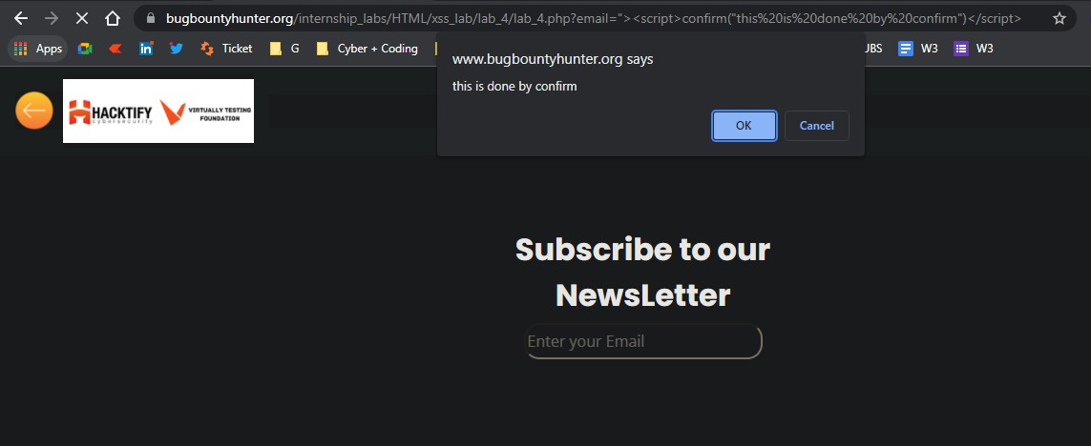

Reference | Risk Rating
Developers hate scripts! | Hard
Tools Used
Google chrome
Vulnerability Description
I found this vulnerability by using different javascript tags like <img>, <svg>, etc.
How It Was Discovered
Manual Analysis
Vulnerable URLs
https://www.bugbountyhunter.org/internship_labs/HTML/xss_lab/lab_5/lab_5.php?email=%22%3E%3 Cimg%20src=x%20onerror=alert(17)%3E
Consequences of not Fixing the Issue
Attackers will be able to read the data that the user is able to access.
Suggested Countermeasures
Developers must sanitize the input of any user by denying entry of any tag or any special character if it is not a valid entry for that particular text field.
References
https://github.com/payloadbox/xss-payload-list

Proof of Concept
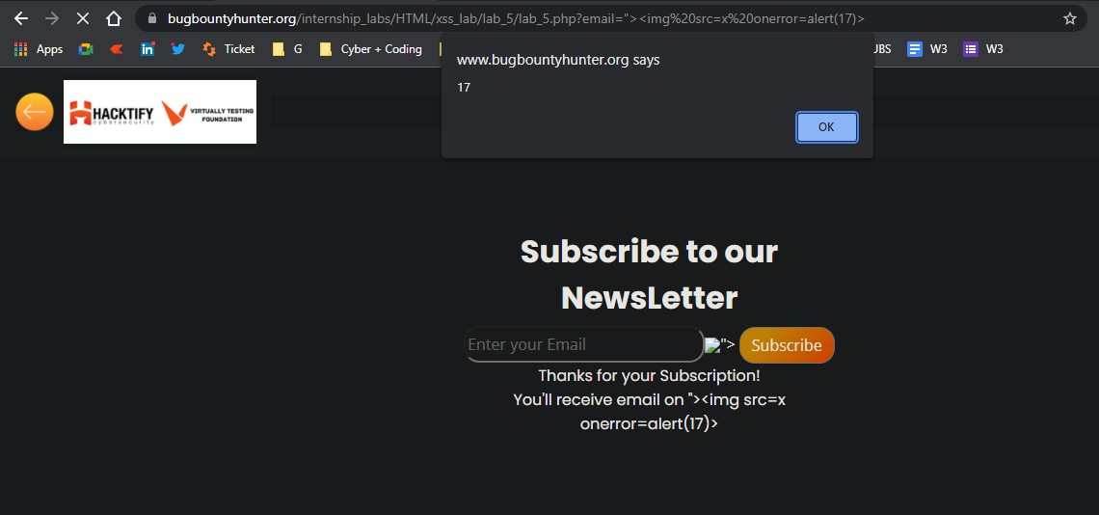

Reference | Risk Rating
Change the variation! | Hard
Tools Used
Google chrome
Vulnerability Description
I found this vulnerability by merging two different tags within a single command as payload to bypass the situation which the developer has created. I used, <script> tag in which I used <svg> tag to bypass it.
How It Was Discovered
Manual Analysis
Vulnerable URLs
https://www.bugbountyhunter.org/internship_labs/HTML/xss_lab/lab_6/lab_6.php?email=%22%3E%3 Cscript%3Ealert(%3Csvg%20xmlns=%22http://theyfuckedme.com%22%20onload=%22alert(document. domain)%22/%3E)%3Cscript%3E
Consequences of not Fixing the Issue
Impersonate and masquerade as the victim user.
Suggested Countermeasures
Developers must sanitize the input of any user by denying entry of any tag or any special character if it
is not a valid entry for that particular text field.
References
https://github.com/payloadbox/xss-payload-list

Proof of Concept
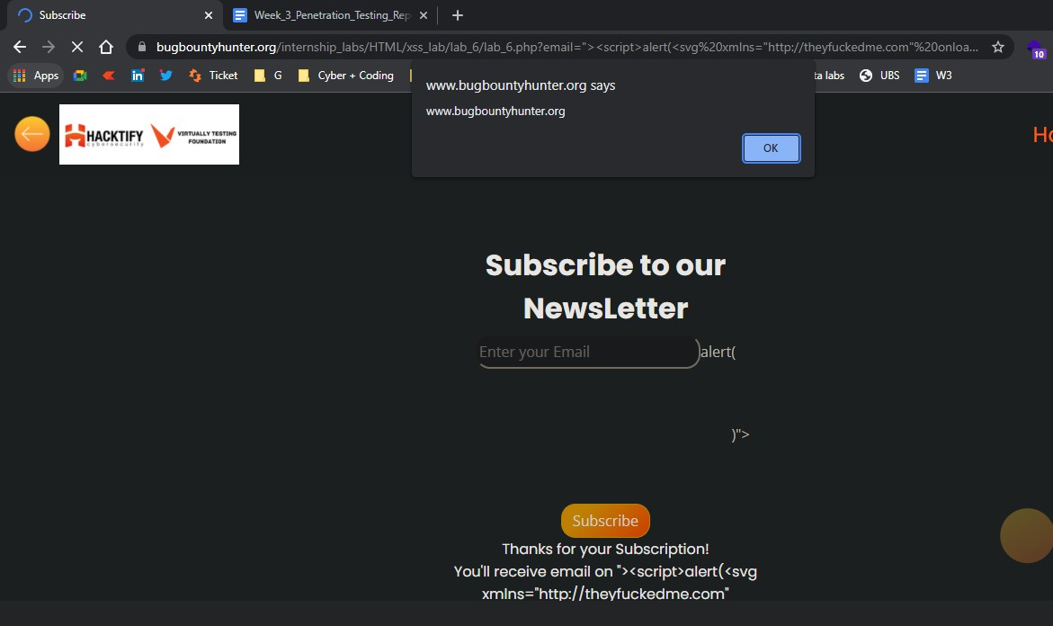

Reference | Risk Rating
Encoding is the key? | Medium
Tools Used
Google chrome and Burp Suite
Vulnerability Description
This vulnerability was found by URL encoding a simple javascript command with the help of Burp Suite.
How It Was Discovered
Manual Analysis and Automated Analysis
Vulnerable URLs
https://www.bugbountyhunter.org/internship_labs/HTML/xss_lab/lab_7/lab_7.php?email=%253c%25 73%2563%2572%2569%2570%2574%253e%2561%256c%2565%2572%2574%2528%2522%2554%256
8%2569%2573%2520%2568%2561%2563%256b%2520%2569%2573%2520%2575%2573%2569%256e
%2567%2520%2555%2552%254c%2520%2565%256e%2563%256f%2564%2569%256e%2567%2522% 2529%253c%252f%2573%2563%2572%2569%2570%2574%253e
Consequences of not Fixing the Issue
Attackers will be able to read the data that the user is able to access.
Suggested Countermeasures
Filtering inputs at the arrival of input data which will run through text fields.
References
https://github.com/payloadbox/xss-payload-list

Proof of Concept
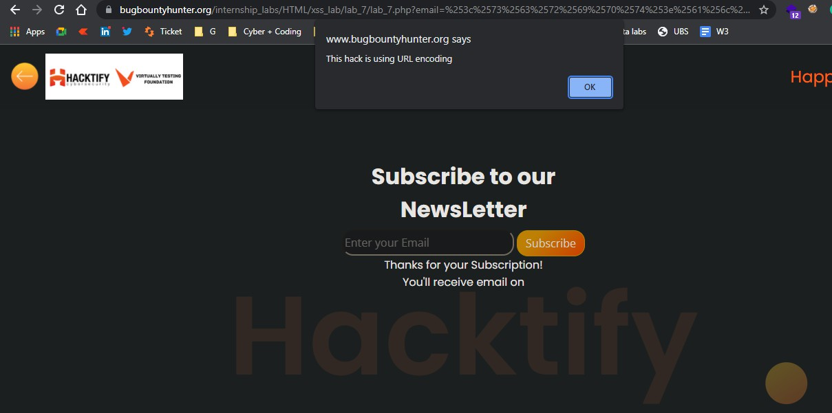

Reference | Risk Rating
XSS with file upload (file name) | Low
Tools Used
Google chrome and Burp Suite
Vulnerability Description
I found this vulnerability by intercepting a file upload request onto Burp Suite tool and renaming the file name to insert payload into filename to bypass all the validation to load payload into the web pages and database to store payload into it.
How It Was Discovered
Manual Analysis and Automated Analysis
Vulnerable URLs
https://www.bugbountyhunter.org/internship_labs/HTML/xss_lab/lab_8/lab_8.php
Consequences of not Fixing the Issue
Hijacking of user accounts, stealing credentials, exfiltration of sensitive data
Suggested Countermeasures
Using appropriate HTTP headers and using Content Security Policy
References
https://github.com/payloadbox/xss-payload-list

Proof of Concept
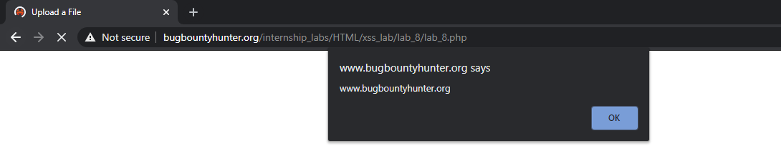

Reference | Risk Rating
XSS with file upload (file content) | Medium
Tools Used
Google chrome
Vulnerability Description
I found this vulnerability by uploading a malicious code file into the file upload section. In malicious code, I used <script> tag to design a malicious code.
How It Was Discovered
Manual Analysis
Vulnerable URLs
https://www.bugbountyhunter.org/internship_labs/HTML/xss_lab/lab_9/lab_9.php
Consequences of not Fixing the Issue
Hijacking of user accounts, stealing credentials, exfiltration of sensitive data
Suggested Countermeasures
Using appropriate HTTP headers and using Content Security Policy
References
https://github.com/payloadbox/xss-payload-list

Proof of Concept
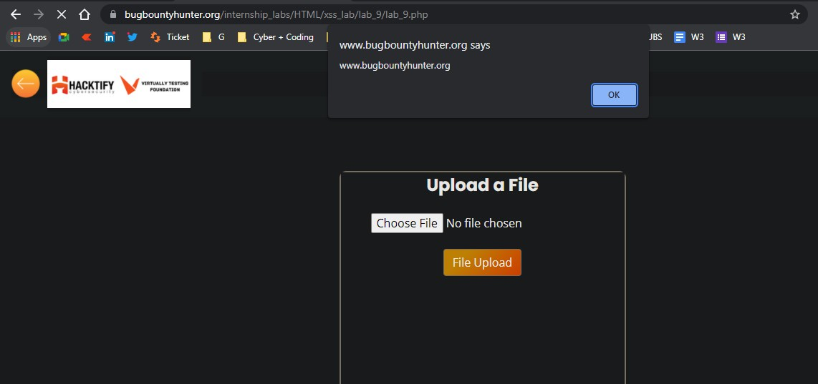

Reference | Risk Rating
Stored Everywhere | Low
Tools Used
Google chrome
Vulnerability Description
I found this vulnerability by registering my into register web page. I inserted a simple <script> tag in all fields which are required to fill for registration. After registration, I tried logging in into the webpage and after the login request I was able to verify that I have successfully implemented a stored XSS attack. Here, these credentials will be stored into the database which can affect other used credentials as well as other database related features.
How It Was Discovered
Manual Analysis
Vulnerable URLs
https://www.bugbountyhunter.org/internship_labs/HTML/xss_lab/lab_10/profile.php
Consequences of not Fixing the Issue
Hijacking of user accounts, stealing credentials, exfiltration of sensitive data
Suggested Countermeasures
Using appropriate HTTP headers and using Content Security Policy
References
https://github.com/payloadbox/xss-payload-list

Proof of Concept
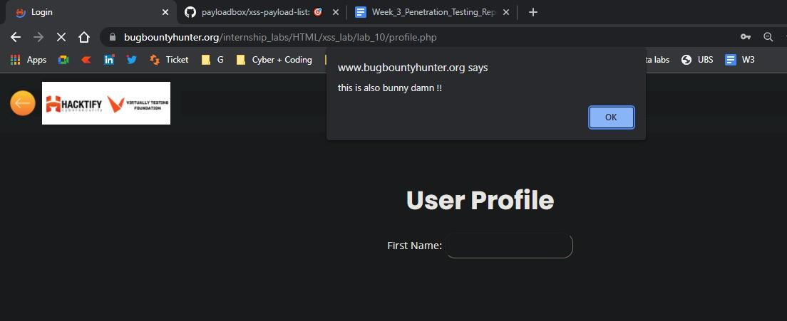

Reference | Risk Rating
DOM’s are Love | Hard
Tools Used
Google chrome
Vulnerability Description
I found this vulnerability by inspecting the source code of the web page and finding out what variables are used in this section. And later on tried to load payload using <img> tag.
How It Was Discovered
Manual Analysis
Vulnerable URLs
https://www.bugbountyhunter.org/internship_labs/HTML/xss_lab/lab_11/lab_11.php?name=%3Cimg
+src+onerror=alert(%22Finallyalldonebybunny%22)%3E
Consequences of not Fixing the Issue
Hijacking of user accounts, stealing credentials, exfiltration of sensitive data
Suggested Countermeasures
Using appropriate HTTP headers and using Content Security Policy
References
https://github.com/payloadbox/xss-payload-list

Proof of Concept
